**Basic Features**

Landlord Features

1. Sign in to account
2. Property details:
   1. Add a property for rent
   2. Edit property information such as number of rooms/bathrooms and monthly/yearly rental prices
3. Payments:
   1. View tenant payments
   2. Send payment reminders to tenants
   3. Accept online payments
4. View currently published property details such as the number of people who viewed the post
5. Applications:
   1. View applications from potential tenants
   2. Accept or decline applications
6. Maintenance:
   1. View maintenance requests from tenants
   2. Mark requests as complete after completion
7. Expenses:
   1. View details per individual property or all properties:
      1. Expenses
      2. Incomes
      3. Net income
8. Ability to communicate with tenants
   1. Ability to send alerts to tenants
      1. Such as nonpayment alerts
      2. Alerts will direct to email they signed up with
      3. Ability to go to text as well if user chooses so

Tenant Features

1. Sign in to account
2. Home page:
   1. View tenant information
      1. Address
      2. Rent price
      3. Utilities included
      4. Roommates
      5. Landlord’s contact information
3. Profile:
   1. Manage tenant’s account information
      1. Name
      2. Email
      3. Phone
      4. Year in school
      5. Expected graduation year
      6. Current address on campus
      7. Number of roommates
      8. Financial aid status
4. Payments:
   1. View payment information
      1. Payment history
      2. Payments due
   2. Make a payment
5. Listings:
   1. View available listings based on filters:
      1. Number of roommates
      2. House or apartment
      3. Price
      4. Walk time to campus
6. Documents:
   1. Sign and submit application to rent property
   2. Sign and submit lease to rent property once application is accepted
7. Maintenance:
   1. Submit maintenance request to landlord

Other Features

1. Does not require login
   1. While logged out, ability to view available rental properties based on your university
   2. Ability to click photos and navigate through rooms in listings
      1. Landlord provides photos
   3. Must log in to apply to properties

**Workflow of the System**

Tenants

1. Rental process
   1. Sign up to login to the system
   2. Search available rental properties
   3. Sign and submit application to rent property
   4. If landlord accepts application
      1. Sign and submit lease
      2. Make payment
2. Payment process
   1. Login to the system
   2. View due payments
   3. Make online payment using debit/credit card
3. Maintenance process
   1. Login to the system
   2. Submit request with description

Landlords

1. Rental process
   1. Sign up to login to the system
   2. Add rental property
      1. Number of rooms
      2. Number of bathrooms
      3. Allowed number of roommates
      4. Monthly rent
      5. Photos
      6. Address
   3. View applications from potential tenants
   4. Accept preferred tenant applications
2. Payment process
   1. Login to the system
   2. View tenants’ payments
   3. If tenant has paid, payment will be automatically received
      1. If tenant has not paid, send reminder of rent due
3. Maintenance process
   1. Login to the system
   2. View maintenance requests from tenants
   3. Once request is taken care of, mark it as complete

**Description of Each Group**

Tenants: Wants…

* A wide array of filter options to find the best housing possible
* Application form on the website
* Easy communication/messages to landlord
* Maintenance tab to explain any fixes needed for landlord

Landlord: Wants…

* Post properties
* Ability to manage properties
* Ability to send alerts to specific tenants

Project/Dev Team: Wants...

* A solid foundation to be built for the app
* Consideration for future dev teams (updates/additions)
* The core functionality to be built so the system can go into use ASAP
  + Updates would then be added to fulfill the overall goal

Company: Wants...

* Lease signing
* Rent/Deposit payments
* Easy search of housing
* Attractive App

**UML Use Case Diagram and Use Cases Involved**

<https://www.lucidchart.com/invitations/accept/5df884ba-657f-40f1-952b-f21bc9ab5694>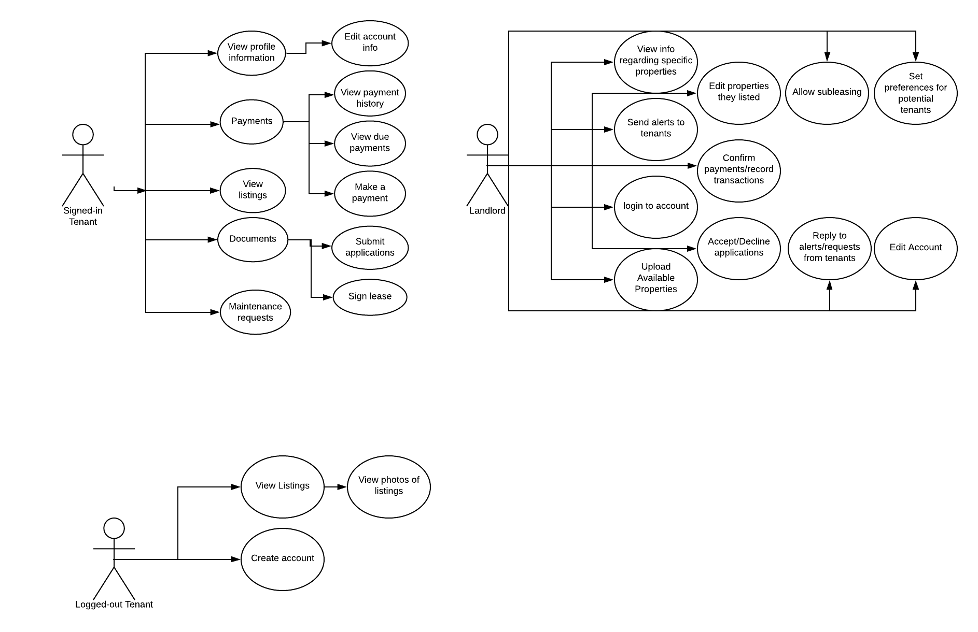

**Non-Functional Requirements and Other Constraints**

No non-functional Requirements have been specified at this time. There is a large amount of functional requirements which may develop nonfunctional requirements as progress on them goes further.